Title of Article (Font: 18 pt)
Author A,^{1,2,}* Author A,¹ Author A² (Font: 12 pt)
¹ Department, School, University, City, Postal code, Country (Font: 10 pt)
² Department, University, City, State, Zip code, Country

Abstract (Font: 12 pt)
This is an abstract. It gives the reader an overview of the manuscript. Abstracts are required for all manuscripts. The Abstract should be self-contained (contain no footnotes or citations to references). (Font: 10 pt)
Keywords: keywords 1, keywords 2, keywords 3, keywords 4 (Font: 10 pt)

Nomenclature
Abbreviations, symbols, and any additional relevant terms should be included in the nomenclature section.

First-order Heading (Font: 12 pt, Sentence case)
The introduction should summarize the rationale for the study and outline pertinent background material, mainly includes the following contents: 1) the reviews of the background in this research field; 2) short description about the related achievement of other scholars [1-2]; 3) explaining the significance and purpose of this scientific research [3,4]; 4) brief introduction about the research work in the paper. (Font: 10 pt)

Second-order heading (Font: 10 pt, Sentence case)

Third-order heading (Font: 10 pt, Sentence case)

Fourth-order heading (Font: 10 pt, Sentence case)

Materials and methods should be described in sufficient detail to allow the experimental work to be reproduced in another laboratory, and to leave the reader in no doubt as to how the results were derived.

Results and discussion (Font: 12 pt, Sentence case)
The results and discussion should be presented in a logical sequence in the text, tables and figures; repetitive presentation of the same data in different forms should be avoided. This section should consider the experimental results in relation to any hypotheses advanced in the Introduction.

Equations should be numbered consecutively in the order they appear in the manuscript. Use equation tools in word-processing software.
$N_{F.LS}=\frac{N_{N.S}}{N_{S}},Qty$ (1)
Table 1 illustrates an example of how to include a Table.

Table 1. Different parameters of hardware modules.
Parameter | Value (mm)
Focal length of POE | 300
Size of POE | 300×300
Height of SOE | 29
Width of SOE | 28
Size of solar cell | 14×14

Figure 1 illustrates an example of how to include a Figure. Refer to the subparts of figure as Figure 1(a).

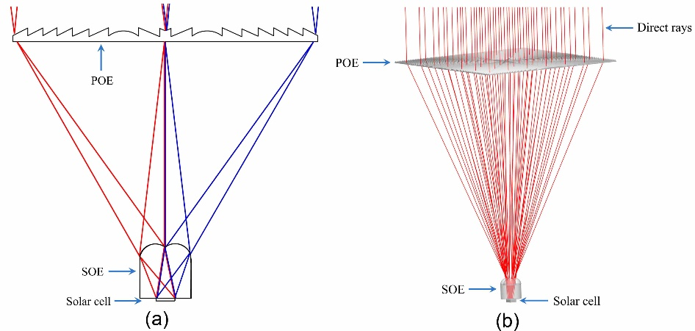
Figure 1. (a) Schematic showing edge-ray mapping in an ideal Fresnel concentrator. (b) Layout of the eight-fold Fresnel-based CPV system with ray-tracing sowing how rays uniformly illuminated the cell.

Conclusion
The conclusions should provide a concise summary of the findings in relation to any broader implications to the field.

Acknowledgement
Any acknowledgement should be mentioned in this section.

Funding
This work was supported by … (Grant No.).

Contributions
Conceptualization, W.I., I.U. and A.H.; Writing—Original Draft, Methodology, Writing—review and editing, W.I., I.U. and A.H.; Visualization, Validation, Data curation, and Resources, J.P. and K.L.; Supervision, I.U. and S.S.; Funding acquisition, Project Administration, M.C. All authors have read and agreed to the published version of the manuscript.

Declaration of competing interest
Competing interest statement is necessary at the end of paper. Such as: The authors declare no conflicts of interest.

Supplementary information
If you have supplementary materials, please upload them when submitting.

References
Reference to a journal publication:
[1] A. Author 1, Title of the article, Journal Name, Volume:Issue (Year) 15-25.
[2] S. Şeko, F. Kılıç, F. Ş. Yılmaz, T. S. Bozkurt, Integrating Acoustic Comfort and Daylighting in Transparent Multi-Purpose Halls: A Simulation-Based Holistic Approach, Journal of Daylighting 12:1 (2025) 167-186.
Reference to a book:
[3] A. Author 1, Book Title, 3rd ed., Publisher: Publisher Location, Country, 2008, pp. 100–140.
Reference to a conference publication:
[4] A. Author 1, B. Author 2, Title of Presentation, in: Proceedings of the Name of the Conference, Location of Conference, Country, Date of Conference (Day Month Year), pp. 100-115.

Please use this “manuscript template” as a guide for preparing your article.
Such submissions can make a greater contribution to the speed and efficiency of our editorial-review process. Please read all of the following manuscript preparation instructions carefully.
All files should be submitted through the online system: https://track.solarlits.com. Acceptable manuscript format is Microsoft Word (.docx) files.

1. Cover letter
Briefly introduce the manuscript's title, significance, and scope, explaining its relevance to the journal's audience. Read the Aims and Scope to gain an overview and assess if your manuscript is suitable for this journal. Highlight the study's unique contributions and confirm that the work is original, unpublished, and not under review elsewhere.

3. Graphical abstract
Please include a graphical abstract with your submission.
- The graphical abstract must provide a concise, visual summary of your article's content, presented in a professional format to engage a broad, interdisciplinary audience.
- Ensure that you have secured all required permissions before including any third-party copyrighted material in your graphical abstract.

4. Title page
The title should be concise (less than 20 words) and informative. Avoid beginning with an article or a preposition.
All authors should have played a significant role in designing and performing the research and in preparing the manuscript. The corresponding author should be marked with an asterisk.
The title page should include the names of all authors, along with their affiliations and email addresses.

5. Figures
- Before inserting images in the file, select the option in the word processor by going to File → Options → Advanced → Image Size and Quality → do not compress images in file.
- Insert Figure without using the text box.
- Number Figures (e.g., Fig. 1) consecutively in accordance with their appearance in the text.
- If a sentence starts with 'Figure', then use the full word 'Figure' followed by the figure number (e.g. 'Figure 1').
- Use font size: 8 for Figure caption.
- For figure annotations, labels, and caption, use font format Arial and font size 8.
- Images must have a resolution of 300 ppi. Horizontal and vertical dimensions of an image should be greater than 1500 pixels and less than 5000 pixels.
- Do not add borders around figures.
- All sub-parts of a figure (e.g., (a), (b), (c)) should be embedded in a single image file. The sub-parts should be referenced in the figure caption using lowercase letters in parentheses.

6. Tables
- When preparing tables, if you are using a table grid, use only one grid for each individual table and not a grid for each row.
- Number tables consecutively in accordance with their appearance in the text.
- Use font size: 8 for table caption.
- Do not use a screenshot of a table from simulation software. Convert the table data into a formatted text-based Table.

7. Equations
- Equations should be numbered consecutively in the order they appear in the manuscript.
- Use equation tools in word processing software.

8. Reference style
All references should be listed at the end of the manuscript. Number the references [in square brackets] in the list in the order they appear in the text. Group consecutive references together in the format [2,3,4], [8-15] or [1,3,4-7]. Do not use space after comma [x,y,z].
Reference to a journal publication:
[1] A. Author 1, Title of the article, Journal Name, Volume:Issue (Year) 15-25.
Reference to a book:
[2] A. Author 1, Book Title, 3rd ed., Publisher: Publisher Location, Country, 2008, pp. 100–140.
Reference to a conference publication:
[3] A. Author 1, B. Author 2, Title of Presentation, in: Proceedings of the Name of the Conference, Location of Conference, Country, Date of Conference (Day Month Year), pp. 100-115.

9. Authors' Contributions Statement
CRediT enables authors to share an accurate and detailed description of their contributions to the published work.
- The corresponding author must ensure the descriptions are accurate and agreed upon by all authors.
- The roles of all authors should be listed using the relevant CRediT categories (Read more about CRediT here).
- Authors may have contributed in multiple capacities.
Authors should write contributions of each author in the manuscript in a separate section.

